4). How memory is managed in Python?

🡪Memory allocation is important to any software developer as writing efficient code means writing a memory-efficient code. Memory allocation can be defined as allocating a block of space in the computer memory to a program. In Python memory allocation and deallocation method is automatic as the Python developers created a garbage collector for Python so that the user does not have to do manual garbage collection.

Example:- a = 10

b = a

if id(x) == id(y):

print("a and b refer to the same object")

output:- a and b refer to the same object

5). What is the purpose continue statement in python?

🡪 Python Continue statement is a loop control statement that forces to execute the next iteration of the loop while skipping the rest of the code inside the loop for the current iteration only, i.e., when the continue statement is executed in the loop, the code inside the loop following the continue statement will be skipped for the current iteration and the next iteration of the loop will begin.

Syntax:- while True:

...

if a == 10:

continue

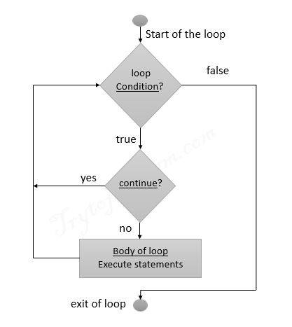 print(a)

**Flowchart continue statement:-**

14). What are negative indexes and why are they used?

🡪A negative index accesses elements from the end of the list counting backwards.Negative Indexing is used to in Python to begin slicing from the end of the string i.e., the last. Slicing in Python gets a sub-string from a string. The slicing range is set as parameters i.e., start, stop and step.

Syntax:- #slicing from index start to index stop-1

arr[start:stop]

# slicing from index start to the end

arr[start:]

# slicing from the beginning to index stop - 1

arr[:stop]

# slicing from the index start to index stop, by skipping step

arr[start:stop:step]